**Q1.** Determine which players have access to which levels of the game? You can use sql/python/R. please make code/query dynamic because there could be n number of conditions & m number of levels.

**Ans**. **select player_id, p_medal_id, level_id from combine order by player_id;**

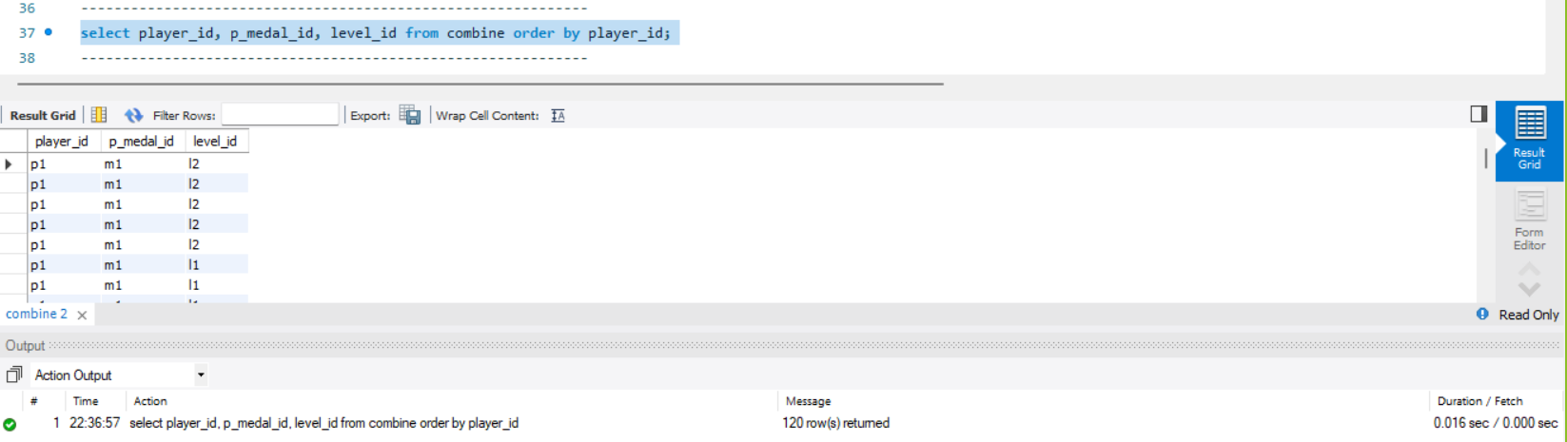

**Q2.** if we do table1 left join table2 what will be the dimension of the output table? What will be the dimension in case of inner join?

**Ans. Left Join -** The dimension for this is 14x3

**select a.time_,a.value_,b.validity_**

**from t1 a**

**left join t2 b on a.value_ = b.value_;**

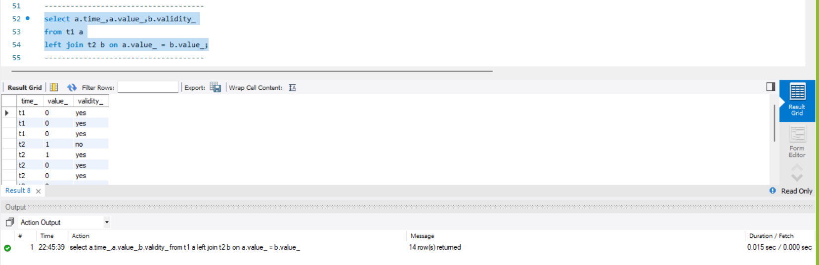

**Inner Join** **-** The dimension for this is 14x3

**select a.time_,a.value_,b.validity_**

**from t1 a**

**Inner join t2 b on a.value_ = b.value_;**

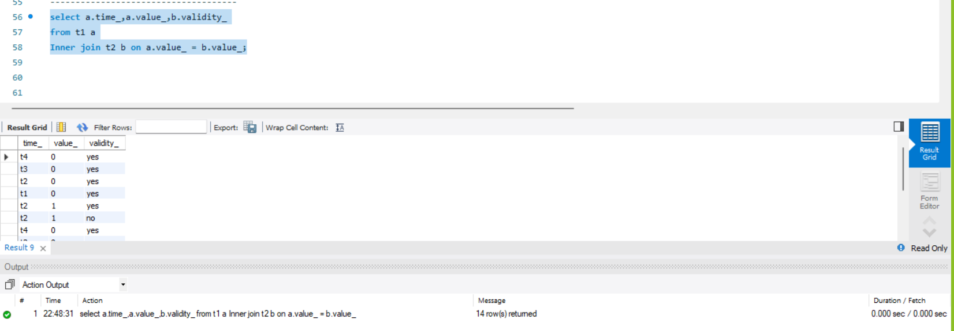

**Q3.** Below table has two columns, date and sale on the date. Please write sql query to get cumulative/running sales from the start of the month till date of the month. For example in the above data cumulative sales would be 100 on 1st jan, 300 on 2nd jan, 500 on jan 3rd,… so on and so forth. Constraint is that you are not allowed to use the window function.

**Ans.**

**select date_, sales_amount, sum(sales_amount)**

**over (order by date_) as cum_sum**

**from sales;**

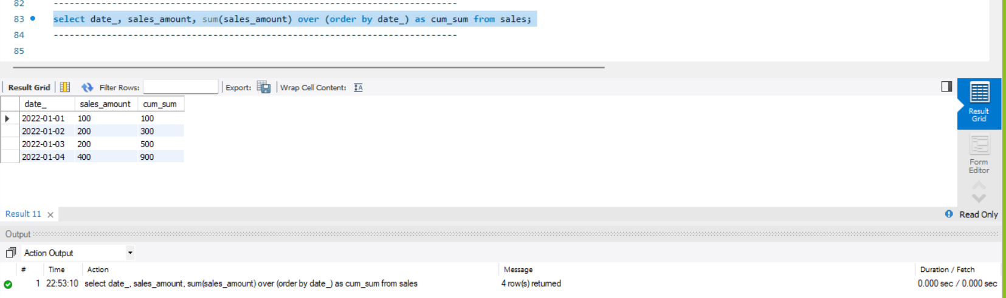

**Q4.** Write the sql query to find out median & average monthly sales from above table. Constraint is that you cannot use join.

**Ans. Median** - The median of the sales.

**with sales as(**

**select**

**sales_amount, row_number() over (order by sales_amount) as row_id,**

**(select count(1) from sales) as ct from sales)**

**select avg(sales_amount) as median**

**from sales where row_id between ct/2 and ct/2 + 1;**

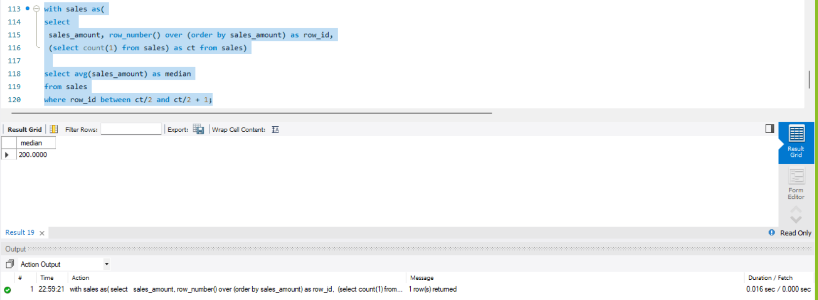

**Average -** The average monthly salary.

**Select date_,sales_amount, round(avg(sales_amount),1) as avg_amt**

**from**

**sales group by date_;**

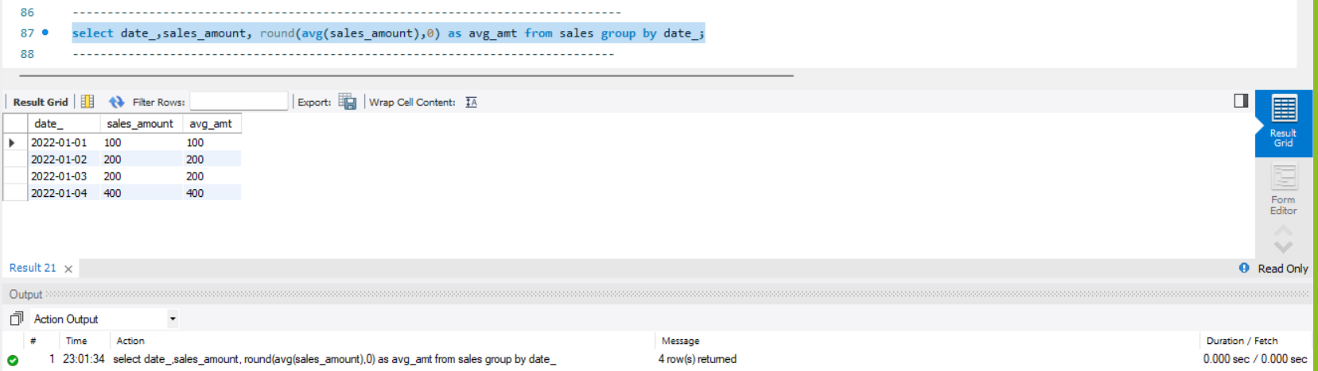

**Q5.** What type of visualization will you use so that you can see overall quarterly sales growth as well as individual region wise sales growth from the same chart.

**Ans.**

